So to change the font of the website you need to go _common.scss file and change the font link and don’t forget to click **watch sass** button.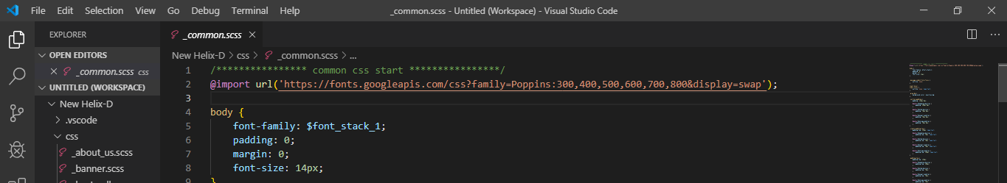

And secondly you need to specify the font name in the _variables.scss file.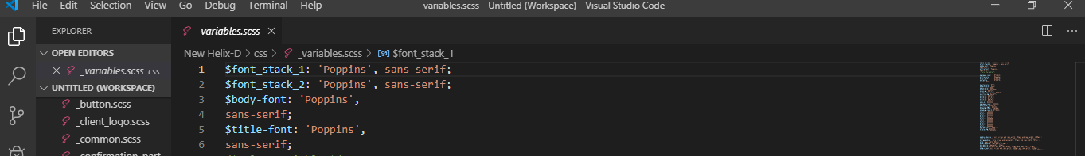

That’s all you have to do now just save the files and check for changes